Regularization is a crucial technique in machine learning to prevent overfitting by adding a penalty term to the loss function. It helps the model generalize better by reducing complexity and controlling the size of the coefficients.

In **linear regression**, the loss function is typically the **Mean Squared Error (MSE)**, and regularization modifies it as follows:

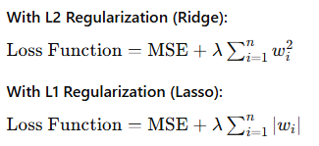

Where:

* λ is the **regularization parameter** that controls the strength of regularization.
* wi​ are the weights or coefficients of the model.

### When to Use Regularization:

* When the model is too complex and is overfitting to the training data.
* When you have a large number of features and want to reduce model complexity.
* When there is noise in the data or you expect some features to be irrelevant.

### Advantages of Regularization:

* **Prevents overfitting**: Helps the model generalize better to unseen data.
* **Improves model interpretability**: L1 regularization (Lasso) can zero out some features, leading to simpler models.
* **Handles multicollinearity**: L2 regularization (Ridge) can handle situations where features are highly correlated.